**User Manual**

**How to Train your Robot**

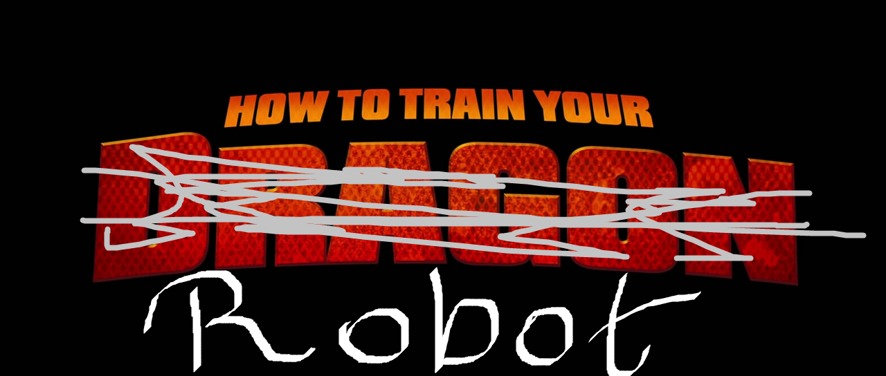

The following text is a description of “How to Train your Robot,” including all the features and functionality the program exhibits.